pertemuan-6.R
r4057266
2026-10-14
# tipe data
# numeric
print ("numeric")
## [1] "numeric"
#a <- 10.5 class
#class (a)
print("integer")
## [1] "integer"
b <- 1000L
class (b)
## [1] "integer"
print("character")
## [1] "character"
#c <- Nama saya adalah Rey
class (c)
## [1] "function"
print ("complex")
## [1] "complex"
d <- 91 + 3
class (d)
## [1] "numeric"
print ("Boolean")
## [1] "Boolean"
e <- TRUE
class (e)
## [1] "logical"
#struktur data
buah <- c(" Apel", "Berry", "Cherry")
buah #vector
## [1] " Apel" "Berry" "Cherry"
list_buah = list("Durian", "Mangga", 10, 20)
list_buah #data list
## [[1]]
## [1] "Durian"
##
## [[2]]
## [1] "Mangga"
##
## [[3]]
## [1] 10
##
## [[4]]
## [1] 20
#matrix
matrix_angka = matrix(c(1,2,3,4,5,6), nrow = 3, ncol = 2)
#matrix angka
#data frame
statistik_Game_RPG <- data.frame(stat = c("power", "mana", "exp"),
marksman = c(100, 24, 50),
fighter = c(80, 40, 70)
)
#Mengurutkan vektor
fruits <- c("banana", "apple", "mango")
sort (fruits)
## [1] "apple" "banana" "mango"
#mengakses Vektor
fruits[1]
## [1] "banana"
fruits [-1]
## [1] "apple" "mango"
#mengganti item
fruits [1] <- "peach"
fruits
## [1] "peach" "apple" "mango"
ML <- statistik_Game_RPG
ML
## stat marksman fighter
## 1 power 100 80
## 2 mana 24 40
## 3 exp 50 70
#menambahkan kolom di DF
#ML <- cbind(ML Assassin = c(100, 24, 50,))
#Mencari dimensi
dim(ML)
## [1] 3 3
#Melihat data frame
#print(ML)
#menggabungkan dua DF
Data_frame1 <- data.frame(
senjata <- c("M4", "AK47", "Uzi"),
skin <- c("dragon","alok", "JB"),
Damage <- c(100, 200, 150)
)
Data_frame2 <- data.frame(
senjata <- c("glock", "shotgun", "Scar l")
)
#print(FF)
#Grafik
#Plot
plot(1 , 3)
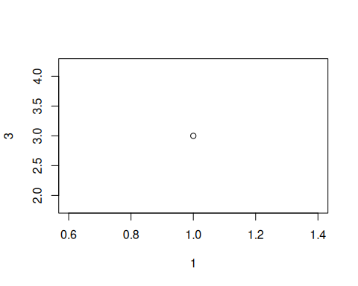
plot(c(1,8), c(7,9))
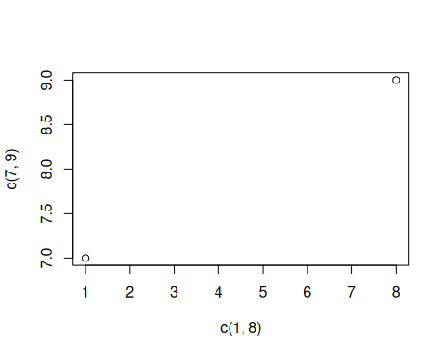
x <- c(1,2,3,4,5)
y <- c(5,4,3,2,1)
plot(x,y)
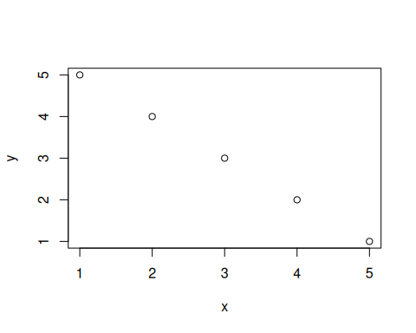
plot(3:10)
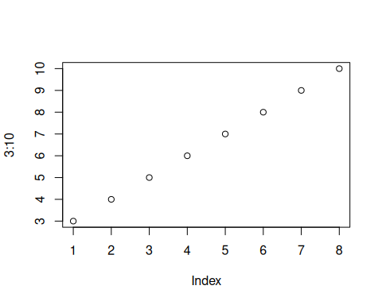
plot(3:10, type = "l")
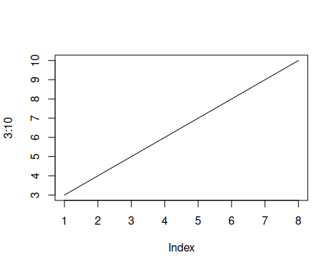
plot(3:10, main= "diagram grafik lurus", xlabs = "ini adalah sumbu x", ylab = "sumbu y", type = "l", col = "violet")
## Warning in plot.window(...): "xlabs" is not a graphical parameter
## Warning in plot.xy(xy, type, ...): "xlabs" is not a graphical parameter
## Warning in axis(side = side, at = at, labels = labels, ...): "xlabs" is not a
## graphical parameter
## Warning in axis(side = side, at = at, labels = labels, ...): "xlabs" is not a
## graphical parameter
## Warning in box(...): "xlabs" is not a graphical parameter
## Warning in title(...): "xlabs" is not a graphical parameter
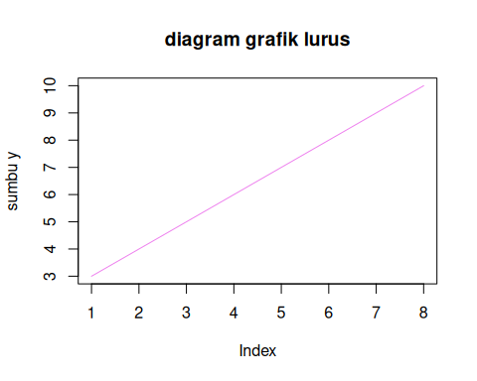
plot(1:10)
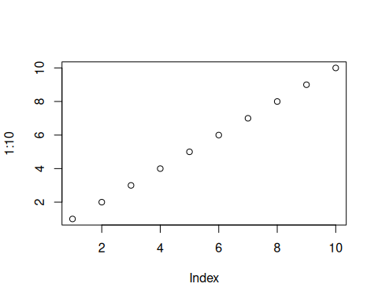
plot(1:10, pch = 10)
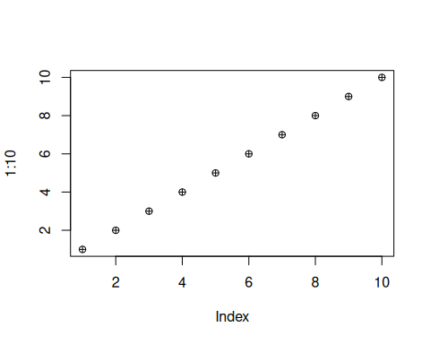
plot(1:10, pch = 10, type = "l")
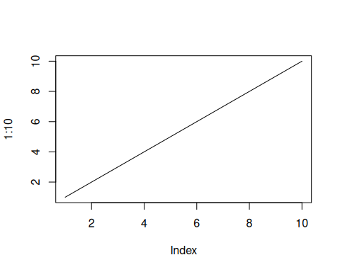
plot(1:10, pch = 10, type = "l", lwd = 404)
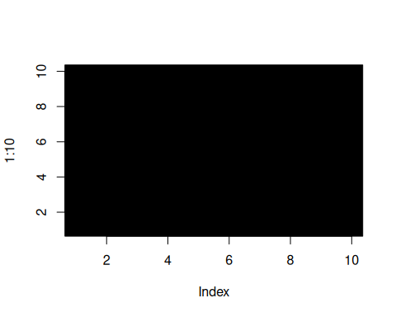
plot(1:10, pch = 11, type = "l", lwd = 4)
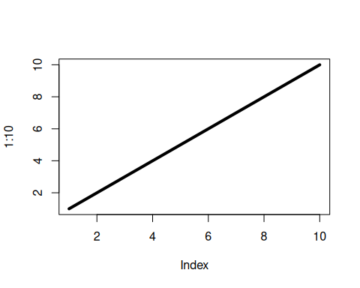
x <- c(1,3,5,7,9)
y <- c(4,5,6,8,9)
plot(x, type = "l", col = "blue")
lines(y, type = "l", col = "green")
